# **Question No.02**

# Bibliography

Anton. (2021). *Calculus.* Washignton D.C: Edith Taylor.

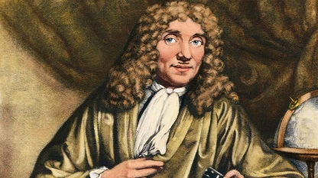 (Anton, 2021)

**P**

**hysical**: Saena primarily faces the physical challenges; as a travelling merchant’s daughter, she has learned to fight; she faces the Dark Fae but suffers weakness in her mental defenses against their magic; Aerim learns to fight from Saena and helps her learn to defend herself mentally.

**M**

**agical:** Aerim is surprisingly resillient to magic and discovers his growing powers as he and Saena venture into the forest to investigate their foe and find the root to the decay of the land; he must ultimately confront the truth that his mother was a Dark Fae and was responsible for introducing a sickness to the human race.

[1]

1. Calculus (Includes family of derivatives and integration mainly)